
Hochschule Hamm-Lippstadt (HSHL)
University of Applied Sciences

BUILD REPORT
Prototyping Project
Component Layout & Assembly Documentation

Summer semester 2026
Team D4

Assembly & Layout Documentation
This report documents the iterative process of arranging and assembling the electronic components of our prototype car. Each figure below represents one lab session or configuration attempt, with a brief description of the observations and issues encountered.

Figure 1: First Lab Session – Initial Brainstorming
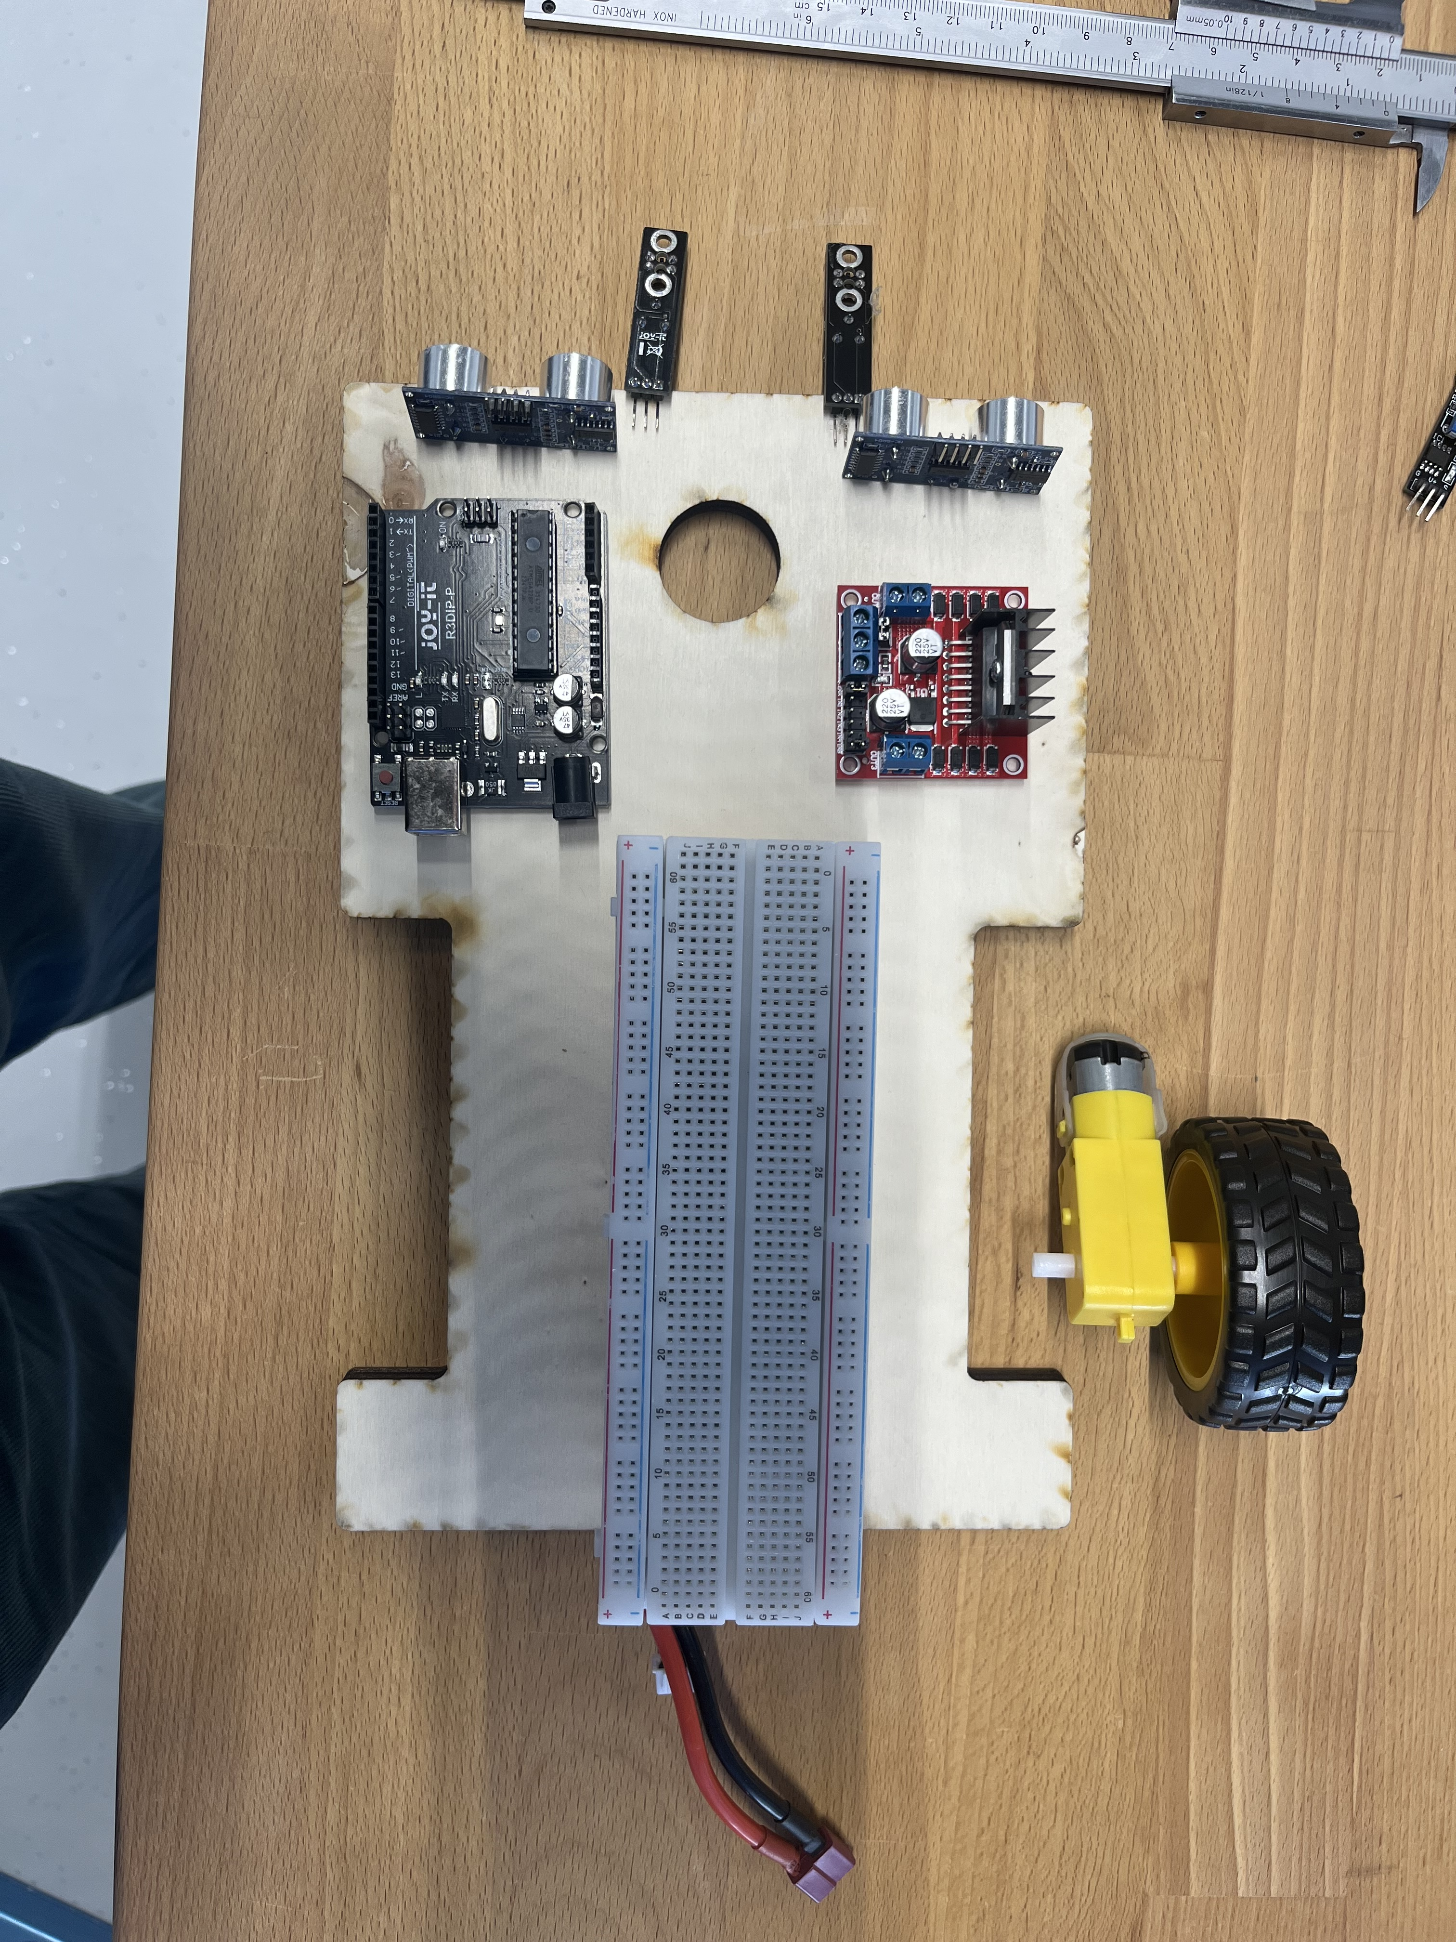
During the first lab session, the team focused on brainstorming and visualizing how the car components would be arranged. In this initial configuration, the battery and the breadboard were stacked on top of each other to explore a compact vertical layout.

Figure 2: Battery Placement – Center of Gravity Issue
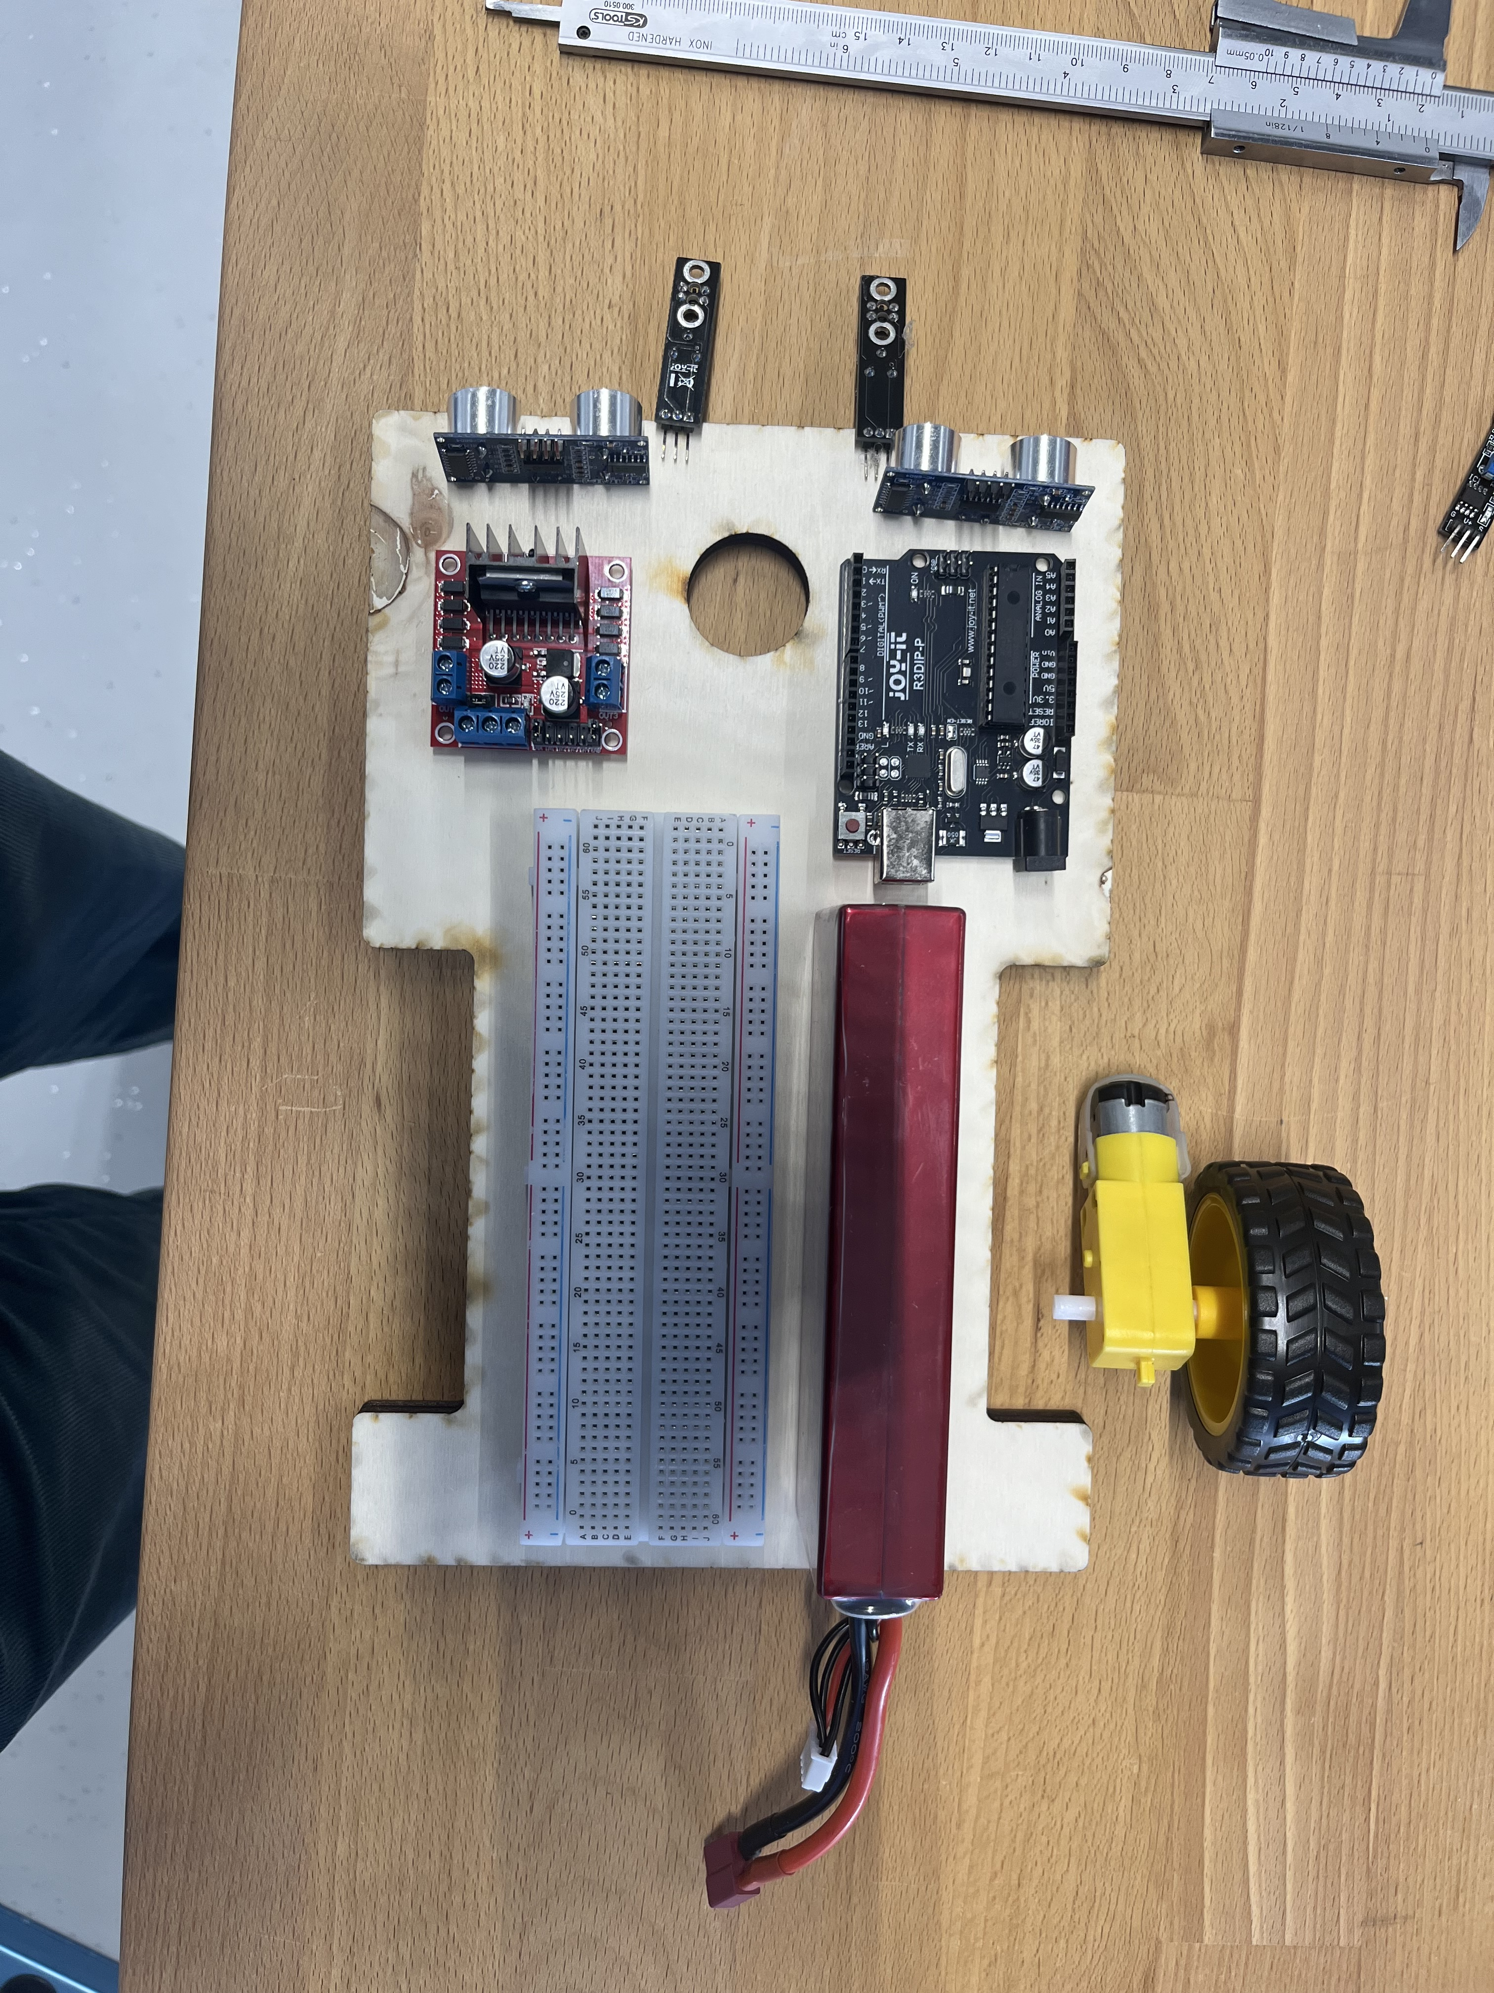
In this configuration, the battery was placed adjacent to the breadboard. However, it became apparent that this arrangement shifted the center of gravity of the car, preventing it from moving in a balanced and controlled manner.

Figure 3: Alternative Layout – Persistent Center of Gravity Problem
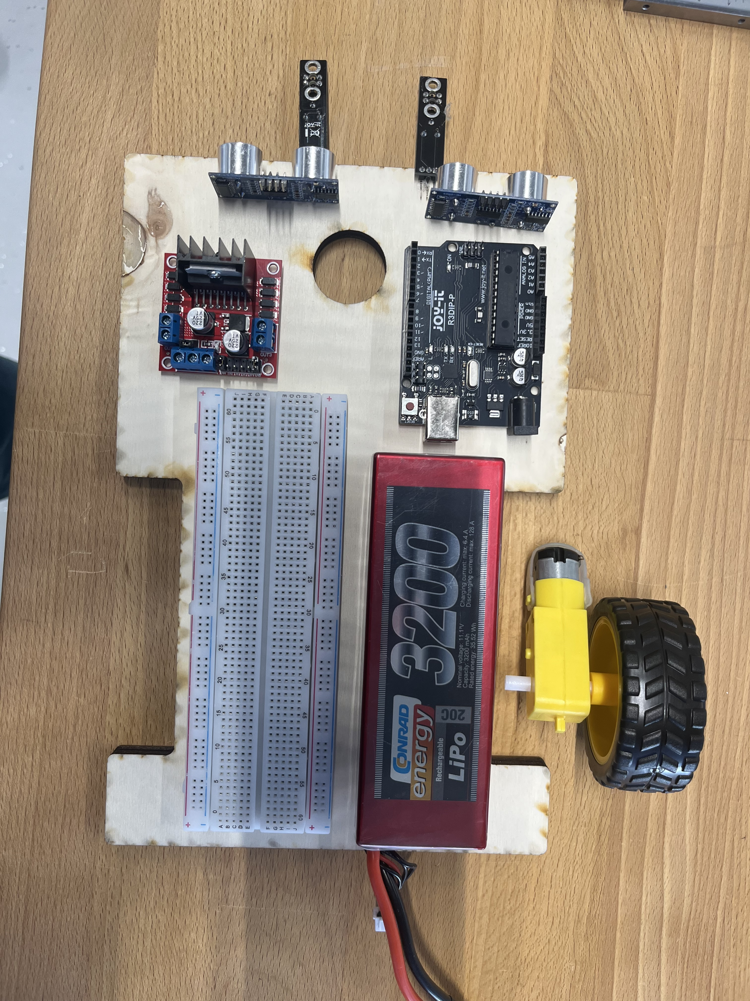
This layout presented the same issue as in Figure 2. Despite the repositioning of components, the center of gravity remained unbalanced. The car was still unable to move correctly, confirming that further redesign of the component arrangement was necessary.

Figure 4: Manual Measurements – Avoiding the Tractor Effect
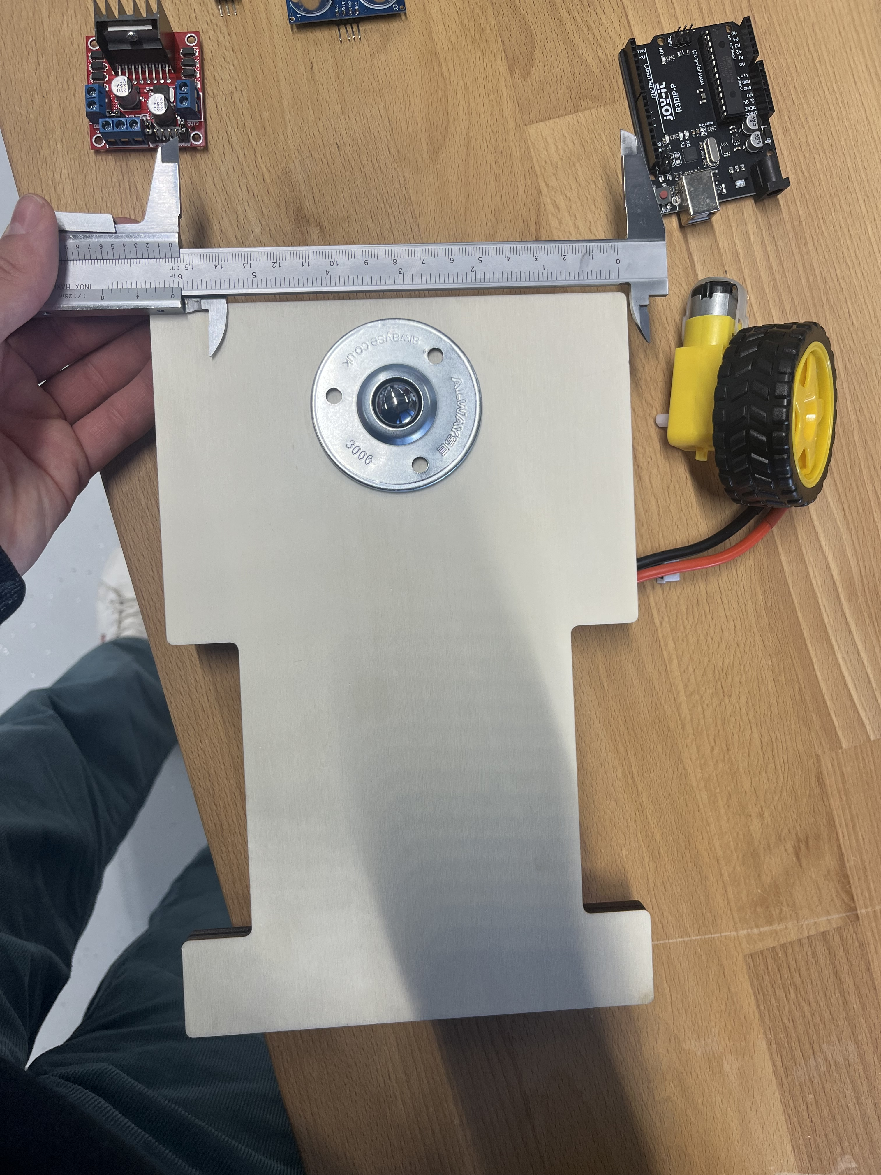
In this step, the team manually measured all car components, even though the dimensions had already been provided in the CAD file supplied by the professor. This verification step was carried out to ensure dimensional accuracy and to prevent the “tractor effect.”
Note: The tractor effect is a phenomenon in which the front wheels of the car lift off the ground due to excessive weight at the rear, causing the vehicle to tilt backward — similar to the behavior of a tractor under heavy rear load. Preventing this effect is critical for stable forward movement.

Figure 5: Final Component Configuration
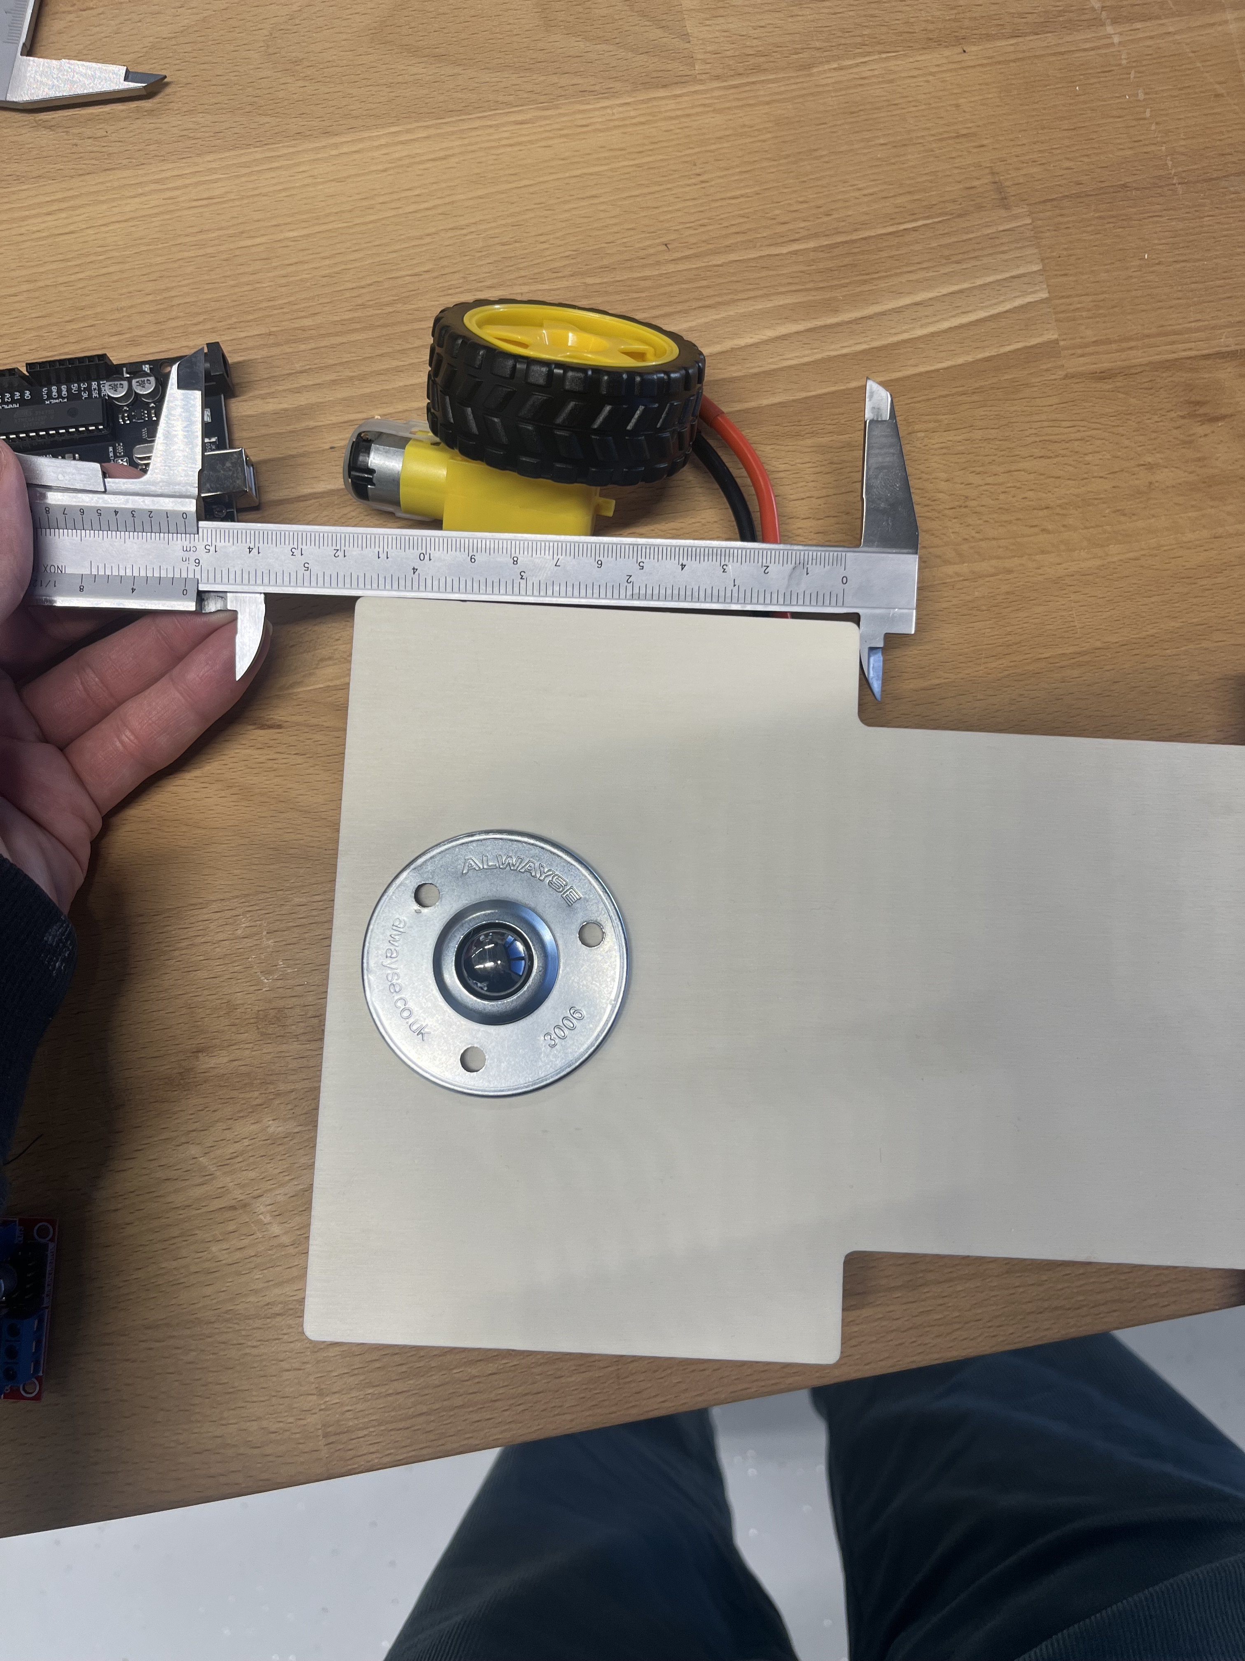
This figure shows the final assembly configuration reached during the lab session. The positioning of all components was reviewed to ensure a balanced weight distribution, correct center of gravity, and stable platform for the prototype car.

